ECS 351 Students: Anselme Dossou & Zilin Zhou
Final project: Automating data extraction from Historic Documents: Case study of Durham, NC.
Inspired by Samuel Bell et al., 2020 (find a pdf of the paper here)

- PROBLEM STATEMENT & RESEARCH OBJECTIVE
Historic documents offer valuable insights into the Earth and climate system, but their usefulness is limited by issues of data quality (noise, illegible text, inconsistent contrast) and format, as many exist only as scanned images or PDFs. To address these barriers, automated techniques for data extraction are required. This project seeks to automate keyword extraction from historical documents, specifically aiming to identify city-waste incineration sites within city directories.
- Methodology
We used a combination of Machine learning and Optical Character Recognition (OCR) workflow enabling us to:
- Preprocess images for robustness
- Segment pages into individual text lines
- Apply Tesseract OCR for text recognition
- Flag lines containing target keyword (“incinerator”)

Here is a step-by-step description of our pipeline:
Step 1: Image Quality Check & Binarization
It’s important to input binary images because grayscale or noisy images introduce recognition errors while binary images reduce ambiguity in character classification. Historically, Tesseract OCR performs best on binary images (only 0- and 255-pixel values). We used Otsu's thresholding which adapts to varying lighting automatically.
Why Otsu's method?
Automatically computes optimal threshold by maximizing between-class variance—robust to varying document lighting and print quality.

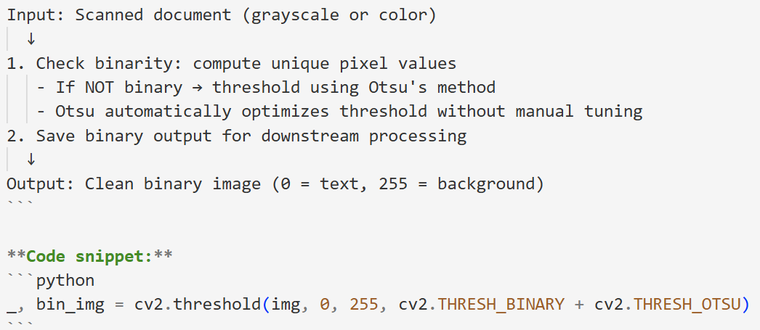

Step 2: Adaptative Line Segmentation
Here we extracted individual text lines from full page (column) images. Traditional approaches group nearby lines into blocks using MeanShift clustering of gaps. Instead, we computed row-wise histogram of black pixels, identified "gap rows" as nearly white regions (≤5% black pixels) and cut at every gap to generate one line per image (put image of the folder). One line per image simplifies downstream Machine Learning (e.g., seq2seq models, line-based classifiers), reduces OCR context confusion (text from adjacent lines) and enables per-line confidence scoring.
For a broader application, we used adaptive padding because different pages/documents have different font sizes. Padding = 15% of detected line height ensures sufficient whitespace for robust OCR, no text truncation at line boundaries and consistent input size for downstream ML models
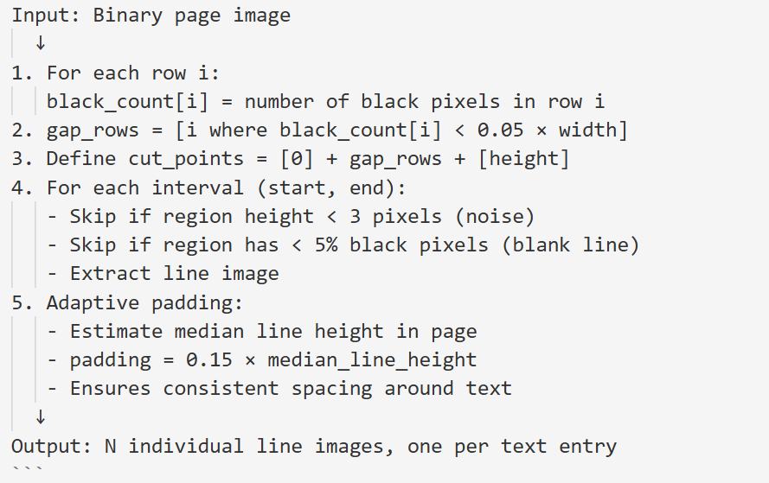

Step 3: Optical Character Recognition OCR
The Tesseract OCR is an Open-source model highly accurate for printed documents, trained on 100+ languages which handles accurately binary historical documents.
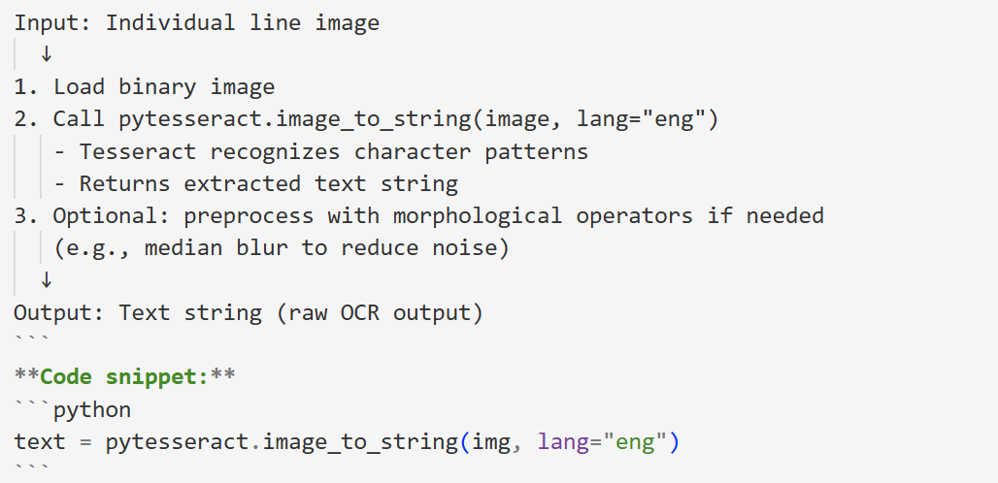

Step 4: Keyword Extraction and Validation
We identified lines containing target keyword (e.g., "incinerator").
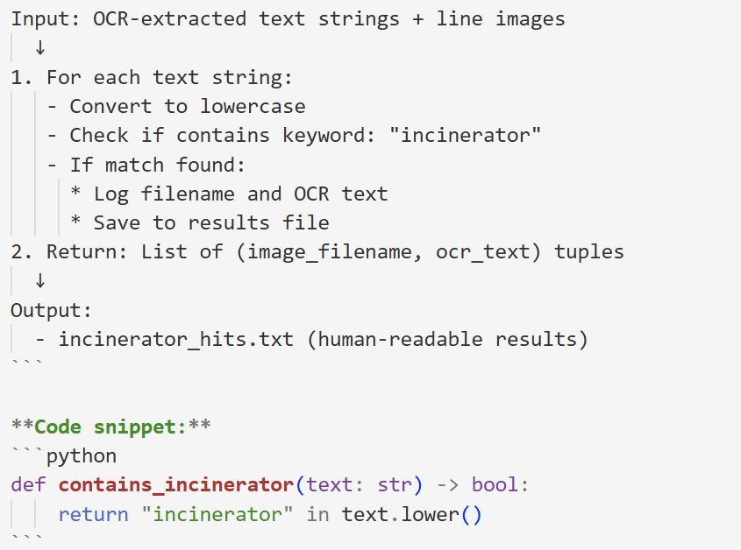

- Computational Efficiency & Reproducibility
Stage | Time/Image | Bottleneck
Binarization | ~50ms | Open CV
Segmentation | ~100ms | NumPy operations (linear in height)
OCR | 500-2000ms | Tesseract
Keyword matching | <1ms | String search
Total | ~1-3 sec per page | OCR

This pipeline is fully scripted and reproducible:
✅ No manual annotation in main pipeline
✅ Configurable parameters (gap_frac, padding %, keyword list)
✅ Batch processing across all documents
✅ Logging of all extracted entities
✅ Easy to version control and audit
✅ Generalizable to other keywords: (Replace "incinerator" with any target entity, Minimal code changes required, Same validation framework applies).

- LIMITATIONS & FUTURE WORK
Current Limitations
- OCR quality dependent on scanned image quality
- Keyword-based extraction only — does not extract full structured data (address, occupation, etc.)
- Single-language support (English only)
- No context modeling — treats each line independently (e.g., misses "incinerator repair" as related)
Future Enhancements
- Full entity extraction: Extract name, address, occupation
- Confidence scoring: Associate each extraction with OCR/matching confidence
- Fuzzy matching: Handle OCR errors and spelling variants
- Deep learning: Replace keyword matching with trained classifier (e.g., CNN on line images)
- Geolocation: Link extracted addresses to historical maps/coordinates
Case study: Locating city-waste incineration sites within city directories in NC.

